Implement an application in Java Script using following:

a) Design UI of application using HTML, CSS etc.

b) Include Java script validation

c) Use of prompt and alert window using Java Script

e.g., Design and implement a simple calculator using Java Script for operations like addition, multiplication, subtraction, division, square of number etc.

a) Design calculator interface like text field for input and output, buttons for numbers and operators etc.

b) Validate input values

c) Prompt/alerts for invalid values etc.

**Flowchart for validating userid**

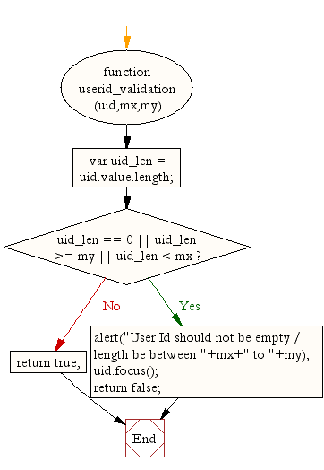

**Flowchart for validating password**

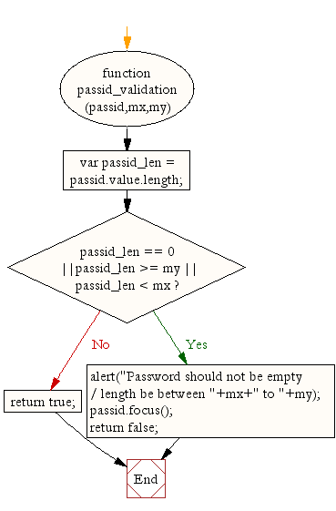

**Flowchart for validating user name**

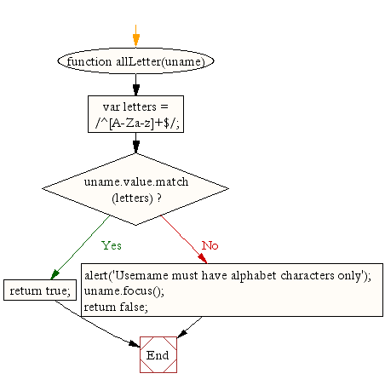

**Flowchart for validating user address**

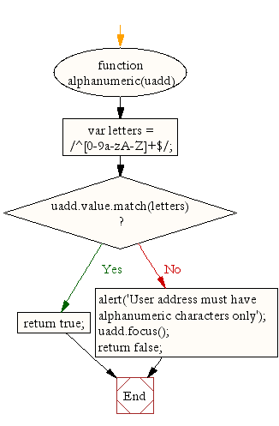

**Flowchart for validating country**

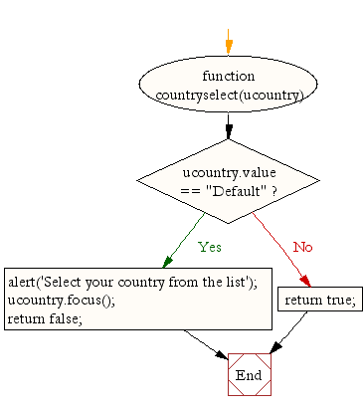

**Flowchart for validating ZIP code**

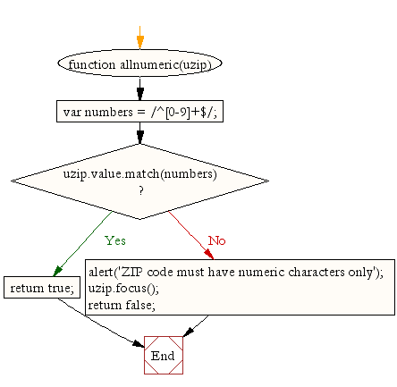

**Flowchart for validating email format**

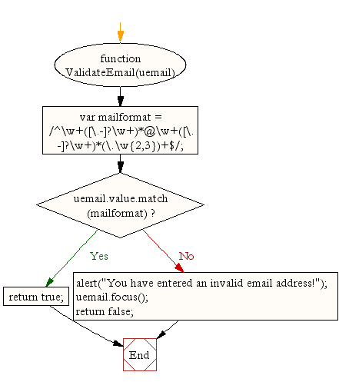

**Flowchart for validating gender**

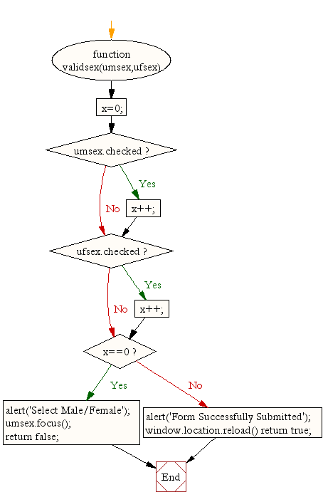

**Flowchart entire JavaScript used for validation of the form**